GREAT WILDERNESS CHALLENGE 2004

– MY OWN PERSONAL CHALLENGE

By Paul White

I set out to do this walk this year in a much poorer state of fitness compared to previous years, and boy oh boy did I know it as the day unfolded.

Registration for the walk took place at 7.00am at Poolewe where the walk ends, and then 150 of us boarded the buses to the start point for an 8.30 start. The walk starts with an immediate climb from 50 feet above sea level up to about 1500 feet, over approximately two miles. As soon as I started I knew then it was going to be a very difficult day, there had been a lot of rain in the days prior and the hills were very wet, and I was struggling right from the start!

The first checkpoint at the top of the first ascent was a very welcome sight, to have a brief rest and gulp down some water and try to get my breath back. I had a camera in my rucksack and although it was turning out to be a beautiful day in this stunning location, my last thought was to start taking pictures. All I could think of was what the hell am I doing here and how can I get round this without being helicoptored off!

I then walked on a rather poor footpath for about two miles, surrounded by towering peaks, before a very steep 1300 foot descent into a beautiful valley called Strath na Sealga. By this time I had started to get my equilibrium back and I was actually quite enjoying myself – I had even got my camera out and had started to take a few pictures as I leapt from dry ground to dry ground to try and avoid the mud and the bogs.

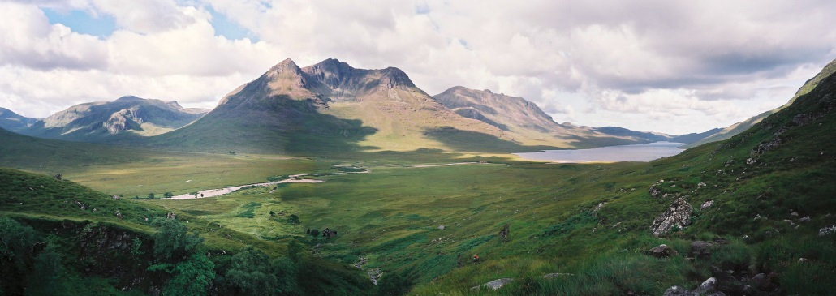
Strath na Sealga and Loch na Sealga

As we dropped down into this broad valley, we had to ford a river, which due to the rains was fast flowing with icy cold water. The water came up to my knees! The technique I was shown first time on the walk, was just to wade through and eventually the water is squeezed out of your boots, and your feet dry out (but you must Vaseline your feet first). We then had to cross half a mile of bog, trying to avoid getting stuck, and then ford another icy cold river.
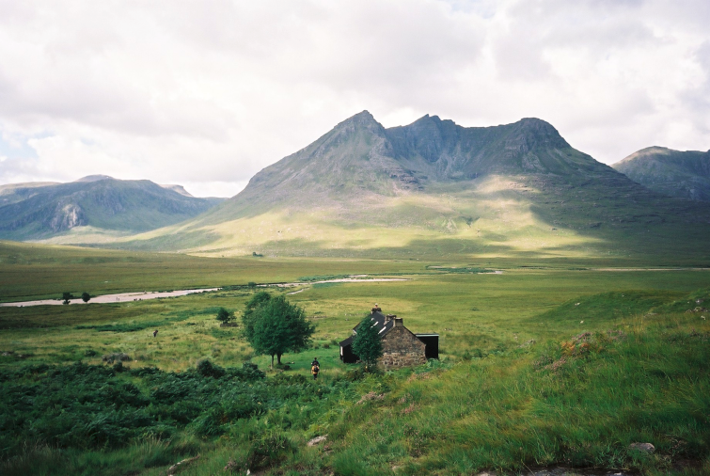
Strath na Sealga and Shenavall Bothy

This Strath is a wide beautiful valley surrounded by tall mountains, and also very green and fertile. It is at least five miles from the nearest road, and has a couple of old bothys in it used by hill walkers for overnight stays. It has a certain poignancy for me as my grandfather, Hector Mackenzie, was a cattle drover (towards the end of the nineteenth centuary ) and this valley was the route they used for taking cattle south to market. As I struggled across the bog I could imagine this now empty valley full of cattle and men.

The route of the walk then follows a path beside a river, and winds its way up a glen that starts to climb and narrow. The first time I did the walk, all I could see at the end of the glen was a waterfall dropping several hundred feet and a wall of hill at the end. I remember asking my brother where we were going and he said “up to the top of there!” As I climbed slowly towards the end of the glen I tried not to look up as I knew what lay ahead.

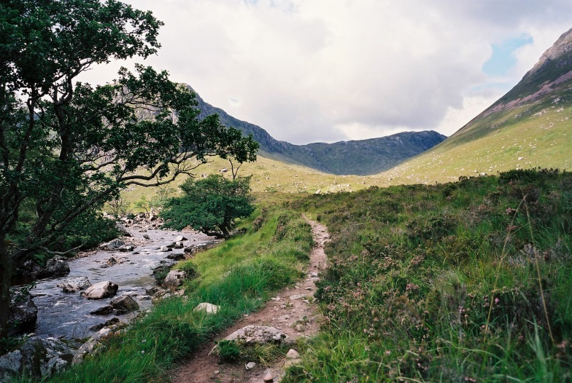
Gleann na Muice Beag

Gradually as the path steepens, I reach the place that’s been giving me nightmares all week, my own personal hell and my severest challenge. The path rapidly becomes almost a continuous staircase, climbing steeply upwards in a series of zig-zag sections. I have to stop and get my breath back every couple of sections, and curse myself for being so stupid as to do this event without being fit. Other people are in the same mess and we encourage each other upwards and onwards, one young girl in particular was really struggling, and I offer words of comfort that this is the worst bit. As I get to the last steepest part I am able only to put one foot in front of another and trudge slowly upwards. Eventually I stagger up to the next checkpoint and drink copious amounts of water and wonder where nurse is hiding!
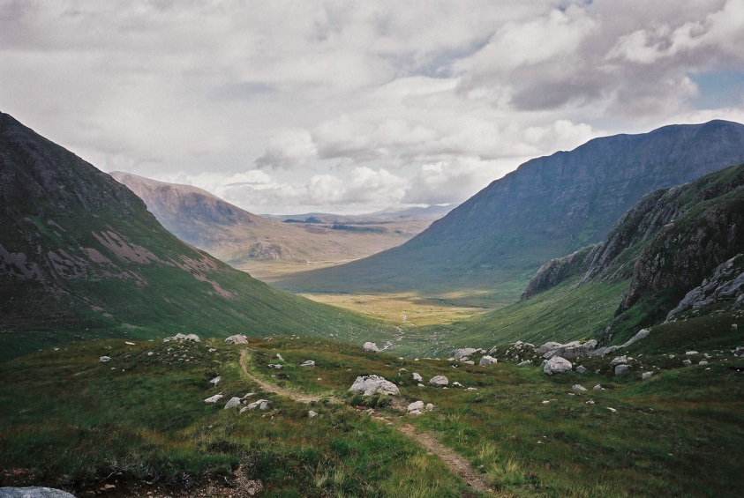
Standing at 1750ft above sea level and looking back, the view is so dramatic, you can see for miles back down the route we’ve come up, as well as over to mountains further north at least twenty miles away. We now set off across a high plateau, on a fairly good path, with mountains to left and right, and then pass a beautiful little hill loch with a small sandy beach.
Looking back
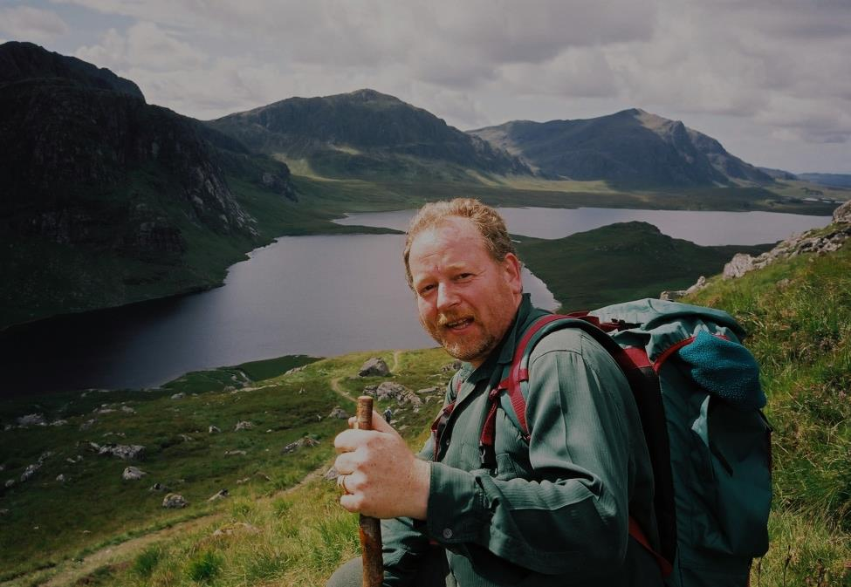
The path then starts to descend to a gap ahead, through which you can see a wall of black rock. Eventually we reach the gap and look down onto a breathtaking panorama – left and about 800 feet below is the Dubh Loch, (Black Loch) surrounded by an amphitheatre of dark mountains, this opens on the right into the long blue Fionn Loch which stretches away as far as the eye can see. The two lochs are separated by a causeway, and at one end is the welcoming site of a blue tent which is the halfway checkpoint at Carnmore. Before we descend, we take pictures of each other with the view behind, after all this is why we have walked so far, for the opportunity to be in this amazing wilderness, to take in the scale of where we are, at least twelve miles from the nearest road, and free of any sight or sound of the modern world. I have to break it gently to the young lady who I swapped cameras with, that she is looking at the half way point a mile ahead, and it was not at the last checkpoint a couple of miles back.
Your intrepid photographer above Carnmore

We descend rapidly down into Carnmore on a horrible broken path, all the time enjoying
the craic with Eric Ross and his wife Pat. Eric has walked these hills for years and years, but is keeping pace with his wife who struggles to get up and down hills due to being not very tall! At the Carnmore checkpoint we are offered soup, a dram or Cabernet Sauvignon!The amazing thing about this walk is the warmth and friendliness of the people on the checkpoints, they spend all day in the middle of nowhere and never a bad word is said to us stragglers, who keep them waiting.

The walk then crosses the causeway as we set off towards Poolewe, twelve miles away. I have changed my socks at Carnmore, and refreshed by a quick sandwich and Mars bar, set off with renewed vigour. I stop on the causeway to look back at the Dubh Loch. The reflection of the black mountains in the water create a dark and brooding mass, and above in the distance is the tiny gap where we came down. It is an overwhelming place that magnetically makes you keep looking back as you walk away from it.

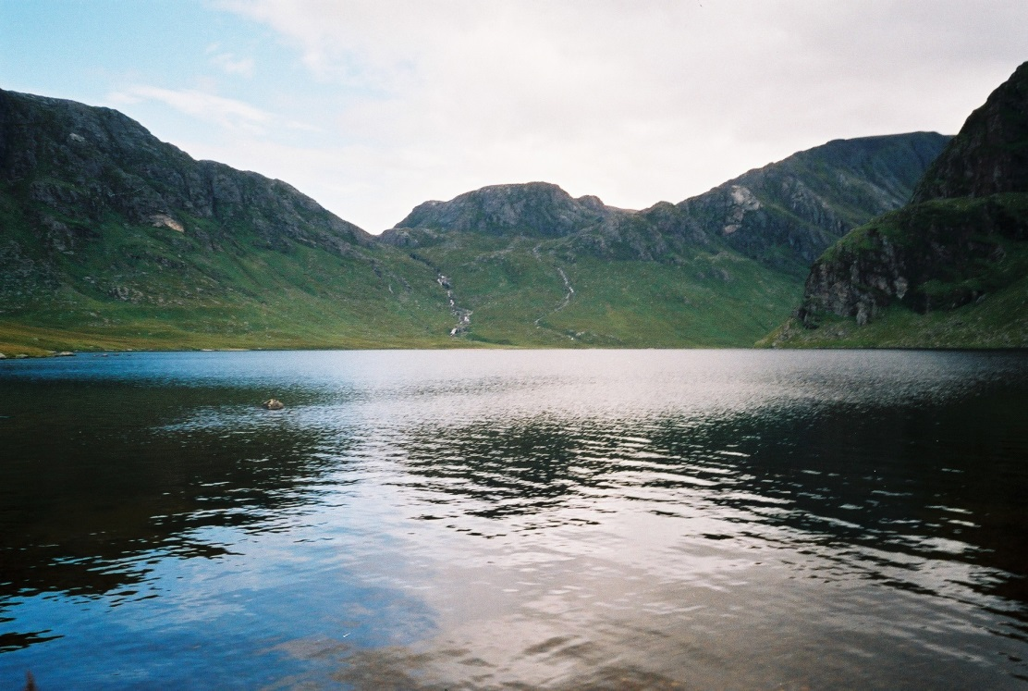
Dubh Loch from the causeway
Dubh Loch from the causeway
The walk now is a steady pace along a good fairly level path, along the length of the Fionn Loch on the right, with mountains at the back of it, and mountains on my left towering up.
We pass the next checkpoint after another four miles and eventually we can suddenly see the sea and the houses of Poolewe in the distance. By this time at about twenty miles legs are starting to get painful, and I can feel my sock rubbing my left big toe – a blister is on the cards! I have to give my legs a talking to at one point as they are starting to let the rest of me down, but eventually I get a second wind and the pace picks up again. Chatting to other walkers helps, but I was passed by a man at least ten years older than me who is going like a train and I feel very, very inadequate!

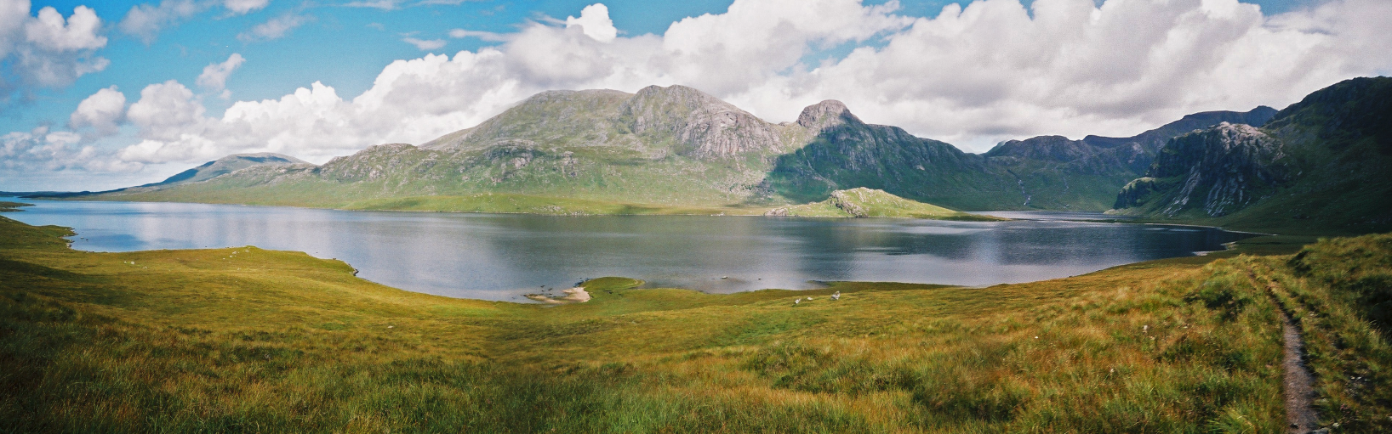
Looking back to Fionn Loch & Carnmore

It’s all downhill from now on, we walk for a mile through a wood on a landrover track, at times having to divert up the banking to avoid huge muddy puddles. In front of me are a mother and son, who try as I might, I cannot catch up with. We had a long chat in the early stages, and at the top of the horrible second ascent I had discovered that this grey haired lady was 67 years old, yet on the flat she had the beating of me!

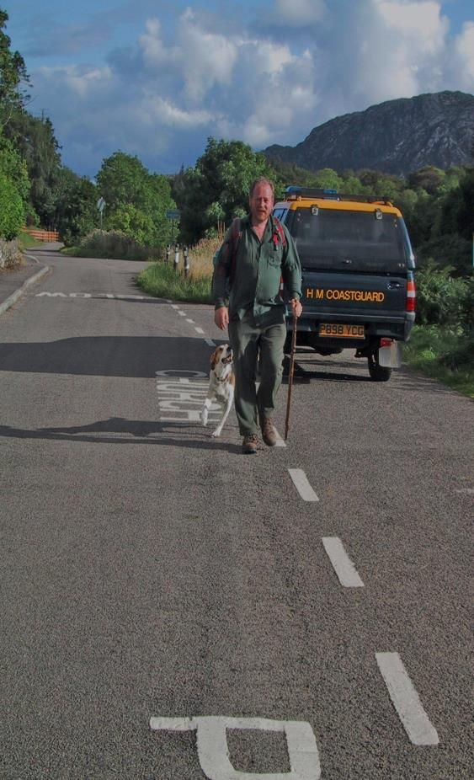
After the last checkpoint at Kernsary there is only four miles to go, but in some ways this is the worst part. You think your nearly at the end, but you’re not. There is still an hour and a quarter of walking ahead, on hard gravel and for the last mile or so on tarmac. By now my feet are very sore, my legs are on fire and only chatting with Eric Ross as I walk keeps me going. I can see his wife Pat a hundred yards ahead, legs going like pistons but I can’t catch up with her.
Journey’s end!

I see the welcoming sight ahead of an elderly couple who always sit by their car, about two miles from the finish, and have peeled fruit, orange juice & slices of Mars bar, and very encouraging words. People like this are what make this event so special. They sit there all day, rain or sun, eaten by midges yet always smiling and encouraging. The road surface changes to tarmac, the river Ewe comes into sight on the left and eventually I see the wonderful sight of the post office at Poolewe about a mile ahead.. This spurs me on and somehow I get a third wind and I crank up the pace.

Suddenly after twenty five hard hard miles I see the finish, and the welcoming sight of the walk officials, my wife and dog. I pass the line to a round of applause and congratulations from all. My cousin Roddy tries to tell me I’m last but I know he’s lying!

Blessed Relief

I feel an overwhelming sense of achievement and satisfaction that masks the stiffness and tiredness. I’ve beaten my fears, I’ve raised £1100 towards the total for the day, and I know that despite my lack of fitness I can still walk twenty-five miles through some of the toughest yet most beautiful terrain in Britain.

Can’t wait for next year!

